Name: _____ANSWERS_______ Score: ___________ / 40 marks
Section A—Multiple choice (6 marks)

 | The isotope of cobalt used to irradiate food to destroy disease-causing bacteria is Co.  The number of electrons in a Co²⁺ ion of this isotope is:  A 25  B 27  C 29  D 33. | A | 1
 | The electron structure of P^{3–} is:  A 2, 8, 5  B 2, 5  C 2, 8, 8  D 2, 8, 2. | C | 1
 | Boron, aluminium, gallium (Ga) and indium (In) occur together in the same group in the Periodic Table because:  A atoms of each of the elements contain the same number of electrons  B they are good conductors of electricity  C neutral atoms of each of the elements have the same number of electrons in their outer shell  D the masses of the atoms of these elements increase smoothly down the group. | C | 1
 | Calcium atoms and calcium ions:  A are chemically identical  B have the same number of electrons  C both react readily with water.  D have the same number of protons | D | 1
 | Element Y has an atomic mass of 25, and a nucleus that contains 12 neutrons. Its chloride is most likely to have the formula:  A Y₂Cl  B YCl₃  C YCl₂  D Y₂Cl₃ | B | 1
 | Which of the following statements about selenium is false?  A Selenium is in period 3, group 16 in the Periodic Table.  B When selenium atoms react with a metal, each selenium atom gains two electrons. C When selenium reacts with chlorine, it forms a molecular compound with the formula of SeCl₂.  D Selenium would be expected to have a reasonably low melting point and to be a non-conductor of electricity. | A | 1

Section B—Written answers (24 marks)

 | Write the formulae for the following ions:  a oxalate  b caesium  c ethanoate  d nitride | a C₂O₄²⁻  b Cs⁺  c CH₃COO⁻  d N³⁻ | 4
 | Name the following compounds:  a Mg(HCO₃)₂  b (NH₄)₃P  c FePO₄  d Cu(OH)₂ | a magnesium hydrogencarbonate  b ammonium phosphide  c iron (III) phosphate  d copper(II) hydroxide | 4
 | Give the formulae of the following compounds:  a manganese(II) hydrogenphosphate  b potassium dichromate  c rubidium sulfide | a MnHPO₄  b K₂Cr₂O₇  c Rb₂S | 3
 | a If the formula of magnesium thiocyanate is Mg(SCN)₂, what is the formula of the thiocyanate ion?  b What is the formula of the sulfite ion?  c Using your answer to b, predict the formula of the tellurite ion.  (hint: Tellurium is Te) | a SCN⁻  b SO₃²⁻  c TeO₃²⁻ | 3
 | Give the formula of an ion which:  a has the electron configuration 2, 8, 8  b has 36 electrons | a P³⁻,S²⁻,Cl⁻,K⁺,Ca²⁺  b As³⁻,Se²⁻,Br⁻,Rb⁺,Sr²⁺ | 2
 | Explain the term ‘isotope’. | Atoms with the same atomic number but different mass number  (ie same number protons different neutrons) | 2
14  15  16  17  18 | “Metals are good conductors electricity.”  Explain why this is so, in terms of bonding and structure.  Draw electron dot diagrams to represent the transfer of electrons and number of atoms required to produce each of the following ionic compounds.  - Calcium fluoride from the reaction of calcium and fluorine.  - Caesium oxide from the reaction of caesium and oxygen.  Draw and label the structure of a typical ionic solid.  Explain with regard to bonding and structure, why ionic solids can not conduct electricity.  Complete the table below that describes the atomic structure of the following:  Potassium ion  Silicon atom  Iodide ion  Write the electron configuration for the following:  - Mg²⁺  - Al  - P³⁻ | Mobility of delocalised electrons within positive lattice.  Electrons enter one end and same number displaced the other end.     [ Ca ]²⁺ 2 [ : F : ] ⁻  ∙∙     2 [ Cs ] ⁺ [ : O : ] ²⁻  ∙∙  -ve ions  +ve ions  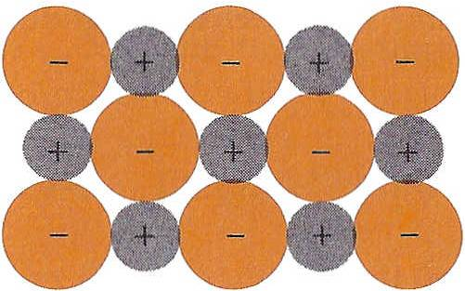  Electrostatic attraction between ions  (must have repeating units)  Lattice made up of positive and negative ions in fixed positions  Charges are not free to move  protons electrons neutrons  19 18 20  14 14 14  53 54 74  - 2,8  - 2,8,3  - 2,8,8 | 2  4  2  2  3  3

